VETERAN’S HIRING TOOLKIT

Developed by

The South Carolina Department of Veterans’ Affairs (SC DVA)

Division of Operations

CREATED June 2022

# Introduction

The United States military depends upon members of the Armed Forces to protect and defend the United States. When Veterans conclude their military service, many seek to transition to civilian careers. To assist with this transition, the South Carolina Department of Veterans’ Affairs designed this toolkit to provide guidance on successfully recruiting Veterans, with a focus on translating military experience to equivalent civilian experience. This toolkit can be used as a reference guide when recruiting to ensure Veterans are given proper consideration. The primary users of this toolkit will be hiring managers.

For purposes of this toolkit a “Veteran” is defined as a person who served in the Armed Forces of the Unites States on active duty, for reasons other than training, and was discharged under honorable conditions.

Topics covered in this toolkit include:

* General information concerning hiring veterans.
* Benefits of hiring veterans.
* Guidance and resources for translating military experience into the civilian workforce.

For additional assistance, please contact South Carolina Department of Veterans’ Affairs at 803-734-0200 or visit our website at [www.scdva.sc.gov](http://www.scdva.sc.gov).

# General Information

## Overview

One of the major hurdles to hiring Veterans is understanding how their skills will transfer into the civilian world. There are many resources are available to assist veterans in converting their military skills and experience into applicable civilian terms for their resume. However, some Veterans may not utilize these services, or they may find it difficult to create a resume with information meaningful to a civilian hiring manager even with these resources. When a resume is not completely translated, or there are still portions that are difficult to understand, employers must be willing to consult the appropriate resources and educate themselves to not risk losing a valuable candidate. Doing so gives Veteran applicants an equitable position in the candidate pool and helps the hiring manager determine if the veteran’s skills and experience are a good fit for the position. The correct interpretation of military experience included on resumes or in applications is imperative to ensure hiring managers are making the best, most informed decisions during the recruitment process when a veteran has applied for the position.

SC DVA recognizes this challenge for hiring managers. To address these concerns, this toolkit was created to provide the guidance and resources needed to confidently translate military experience and maximize the recruitment potential of veterans.

# Benefits of Hiring a Veteran

## Why Hire a Veteran?

Hiring Veterans has many benefits for employers. Military personnel are often cross trained in multiple skills and have experience in varied tasks and responsibilities. Many Veterans have learned what it means to put in a hard day's work and appreciate the challenges and satisfaction of a job well done. This experience provides skills that can transfer to positions in the civilian workforce.

Veterans have a great deal to offer potential civilian employers, including valuable non‐technical skills, such as leadership, decision making, dependability and attention to detail. Many employers report that veteran employees are not only excellent team members, but also tend to have a higher rate of retention. Veterans bring with them the skills to get the job done in a timely and efficient manner, such as management acumen, success working with teams, a focus on accountability and a sense of responsibility.

Specifically, Veterans bring with them the following characteristics that employers find valuable:

* Working well in a team. Teamwork is considered an essential part of daily life and is the foundation on which safe military operations are built.
* A sense of duty. Responsibility for job performance and accountability for completing missions are something service members value.
* Self‐confidence. Holding a realistic estimation of self and ability based on experiences is expected of each service member.
* Organization and discipline.
* A strong work ethic. In the military, the mission always comes first. Service members are results‐ oriented and priority‐driven.
* Commitment. Even under difficult or stressful situations, veterans are committed to following through on assignments
* A variety of cross‐functional skills, such as extensive training on computer programs and systems, interacting with various people with different skills to accomplish a task, and coordinating and troubleshooting problems in novel and known conditions.
* Problem solving quickly and creatively.
* Adaptability to changing situations.
* Dedication to following rules and schedules.
* Conflict resolution.
* Honesty and integrity.
* Strong communication skills.

These skills are frequently **transferable** from military experience to the civilian workforce:



Leading multi- service communications team



Developing communication strategies and programs



Managing marketing strategy



Being a spokesperson at unit/regional levels



Responding to media inquiries



Directing national and local outreach campaigns



Conducting Interviews



Developing implementation strategies/plans



Providing sound advice and counsel



Writing implementation plans for field headquarters



Orchestrating branding campaign/ company vision



Leading seminars



Leading public relations focused trips



Developing social media plans



Initiating company blogs



Producing e- newsletters



Tracking results



Translating technical information into easy-to-understand text

The above skills that veterans typically possess may allow for smooth transition into the following key civilian career sectors:



Information Technology

Public Service

Project Management

Risk Assessment & Awareness

Education

Engineering

Planning & Logistics

Healthcare

Communications

# Guidance for Recruiting with Veteran Preference

The process to recruit veterans is predominantly the same as any other recruitment, with a few slight adjustments.

## Job Postings

## Employers should have a policy that defines Veterans’ Preferential Hiring Practices that should include but is not limited to first look for job postings, take into consideration Disabled Veterans, career tracks for advancement, and Veteran box on application for easy identification.

Upon implementation of the Veteran’s Preference, applicants will be required to indicate if they are a veteran when completing the State Application for Employment. Applicants identifying as veterans will be required to submit DD Form 214, Certificate of Release or Discharge from Active Duty, with the application. Employers Human Resource (HR) offices will be responsible for verifying Veteran eligibility and may contact the South Carolina Department of Veterans’ Affairs for assistance. An applicant that claims eligibility but fails to provide the accompanying documentation (Form DD Form 214) will not be eligible for the Veteran’s Preference.

## Application Review



REMINDER

Once the posting has closed, the agency HR office will screen the applications to determine who meets the minimum training and experience requirements. Applications which indicate the applicant is a Veteran will be further reviewed to ensure the applicant has provided the required supporting documentation. The agency HR office will provide hiring managers with information from qualified applicants and identify any applicants eligible for the Veteran’s Preference. The agency HR office will ensure the confidentiality of the contents of the DD Form 214 and will not share the personally identifying information (PII) contained in the form with hiring managers. If one or more eligible veteran applies and meets the minimum training and experience qualifications, then at least one veteran must be interviewed, in accordance the Veteran’s Preference.



Only veterans who submit DD Form 214, received verification of eligibility, and meet the minimum training and experience requirements for the position will receive Veteran Preference.

If an applicant claims Veteran status but does not provide the required documentation (DD Form 214), he or she will not be eligible for the Veteran’s Preference.

It is essential for hiring managers to understand the applicant’s skillset and previous experience to determine if they have the necessary knowledge, skills, and abilities to perform the duties of the recruited position. This toolkit and the resources provided can assist with this process.

There are an endless number of terms used for military experience

and skills. The following sections provide resources that assist with the translation of military titles, skills, etc., into civilian equivalents. Hiring managers should review the information provided in this toolkit to become familiar with the available resources.

**Application Review: Military Experience and Civilian Equivalents**

This section provides the following information to assist in interpreting military experience provided on a veteran’s resume:

* Charts provided by the Department of Defense Transition Assistance Program (DoDTAP)
  + DoDTAP provides information and planning assistance for transitioning service members and their spouses. On the linked web page, DoDTAP offers the following charts to provide insight into civilian equivalents of military fields and intangible skills service members developed during service.
  + Military Fields and Civilian Equivalents
    - This chart provides the civilian equivalent of military fields and is a great tool that can quickly be referenced by hiring managers seeking to understand how one of these military fields relates to the civilian world.
  + Service Members’ Intangible Skills (Provided by DoDTAP)
    - This chart gives an overview of the intangible skills gained by a service member during his or her time in the military, and the skills and leadership experience gained at each military stage.

Military Titles and Civilian Equivalents:

* provided by “From Military to Civilian: Resume Translation,” a military.com article Provided by Department of Defense Transition Assistance Program (DoDTAP).

### DoDTAP: Military Fields and Civilian Equivalents

### DoDTAP: Service Members’ Intangible Skills: A Primer

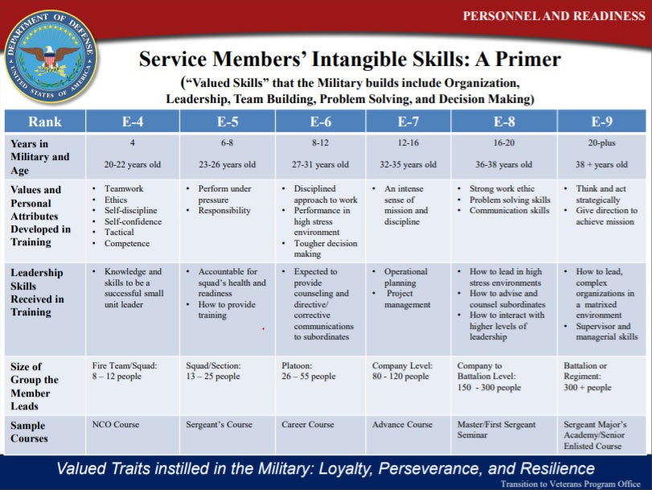

**Common Military Titles and Civilian Equivalents**



Military Title

Civilian Equivalent



Commander

Director/Senior Manager



Executive Officer

Deputy Director



Field Grade Officer

Executive Manager



Company Grade Officer

Operations Manager/Section Manager



Warrant Officer

Technical Specialist/Dept.

Manager



Senior NCOs

First-Line Supervisor



Infantry

Security Force



First Sergeant

Personnel Manager



Squad Leader

Team Leader/Chief



Supply Sergeant

Supply Manager/Logistics Manager



Operations NCO

Operations Supervisor

Provided by “From Military to Civilian: Resume Translation,” a military.com article

**Additional Resources to Translate Military Experience to Civilian Skills**

In order to better understand the translation of military experience to the civilian workforce, consider using the below resources. Click on the hyperlink to navigate to the referenced tools.

## Military.com

Military.com provides news and information about benefits available to military members, veterans, their families, and those with affinity to the military. Further, this website provides assistance to veterans looking to transition into the civilian workforce, offering a military skills translator that can be used to create their resumes. This is also an excellent tool for employers to utilize to identify the equivalent civilian position for a military job title. After inputting the branch of service and the military job title or job code listed on a resume into this tool, it will search and provide several equivalent civilian job titles. While this tool does not provide a one‐for‐one match, it does provide multiple civilian jobs that the applicant may perform well in, based on the skills and experience associated with their military position.

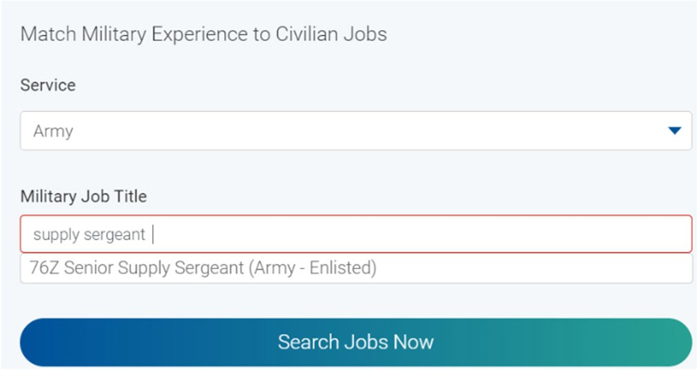

When you begin to enter a military job title, a drop‐down list will give options to choose from. Select the correct title. The site will search civilian jobs that match with the military experience.

This tool will then provide a list of equivalent civilian jobs. In the example to the right, 643 equivalent civilian jobs were produced. Reviewing the jobs listed will provide insight into the types of civilian jobs associated with the applicable military classification.

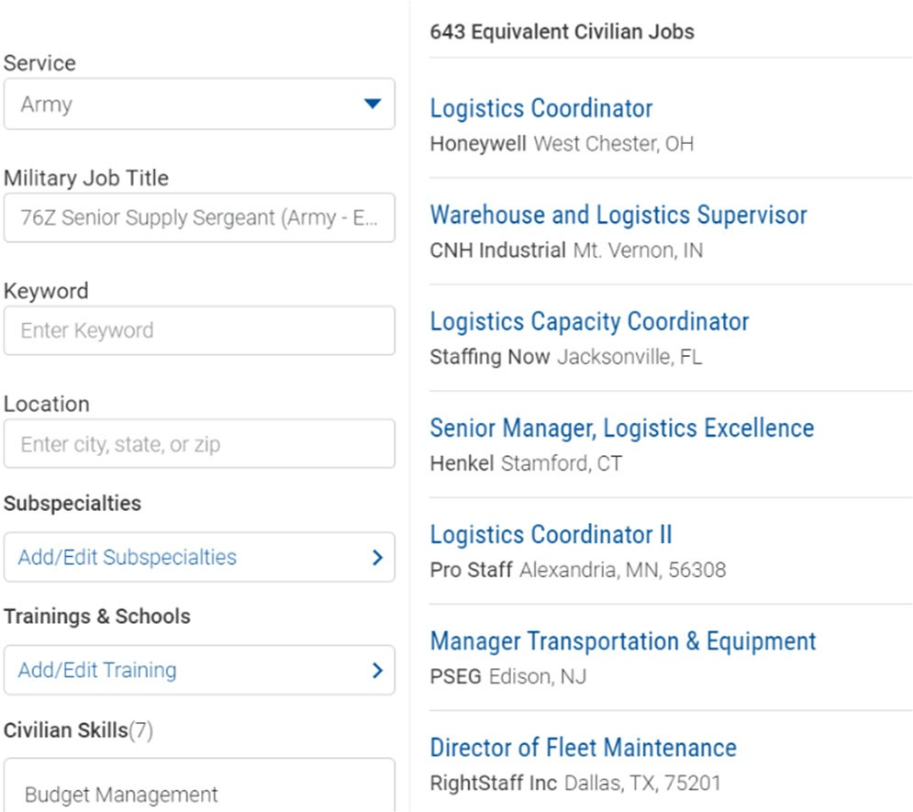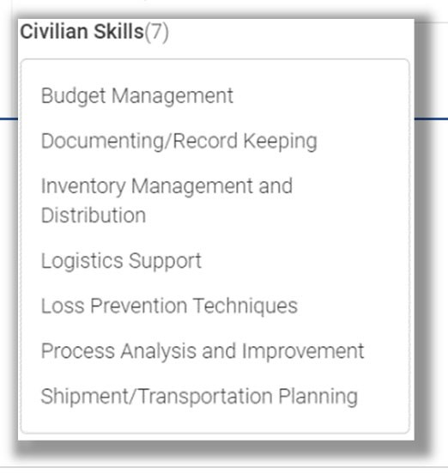

The left side of the results page provides additional search criteria options. Because the tool’s primary users are veterans searching for jobs, you may not need or care to utilize most of these fields. However, the last search criteria, **“Civilian Skills,”** is very valuable. Here, the search tool provides key skills associated with the military classification that would be useful in the civilian workplace. You can use this to determine if the applicant has the necessary skills for the recruited position.

## “My Next Move” for Veterans:

“My Next Move” assists Veterans looking for careers in the civilian workforce. Like military.com, “My Next Move” offers several search engines to help find a career path that parallels with a veteran’s skills and experience. Veterans can search careers three different ways: by key word, by industry or by careers comparable to their military job. Using any of the search options, the tool will provide a list of careers that are compatible based on the relevant search criteria. Each career listed has an associated information page filled with useful information about the career, including:

* Other titles this position may go by.
* Equivalent titles for the position across all five branches of the Armed Forces.
* A general position description.
* Sample duties.
* Typical personality of a person in the field.
* Technology that might be used.
* Job outlook.
* Education experience recommended, and the knowledge, skills, and abilities a person commonly possesses in this field

While this site is targeted for veteran use, employers can also use it as a resource using the two modified search methods described below.

1. If a veteran provides their military title or job code on their resume, input this information into the “Find careers like your military job” field using the military branch and title. Click “Find” and see if the position you are recruiting for is listed as a similar career. Selecting the career will produce other possible titles for the position and detailed information about the career. You can use this information to cross reference with the veteran resume.
2. Use the “search careers with key words” field to search for your position by title or key word. From the populated list, select the closest matched title. On the top of the information page, you’ll see likely military equivalents of this position. You can also cross reference the veteran’s resume to identify other similarities provided on the information page.

Screenshots of these two search methods are on the following pages. In the scenarios provided, a hiring manager is recruiting a Procurement Manager.

## Example 1: “Find careers like your military job”

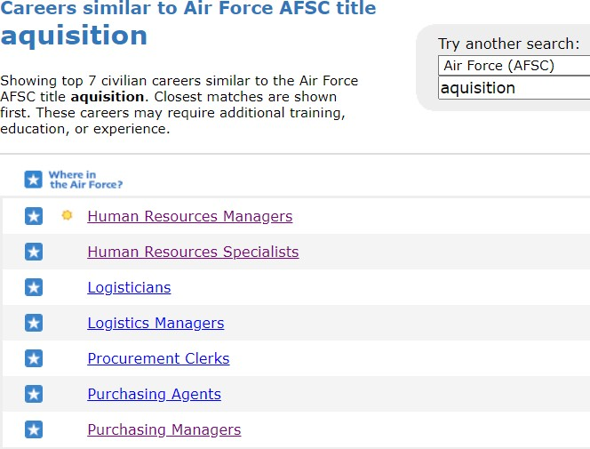

### Step 1:

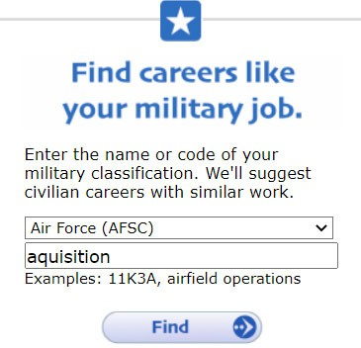

Enter the branch of the Armed Forces that the veteran listed on his or her resume

Enter the military classification code, name of the position, or key word from the resume.

Click “Find” to identify related civilian careers that match well.

### Step 2:

The search engine will display the related civilian careers. The applicant’s resume included a job title with the key word “acquisition.” Similar civilian careers identified include purchasing manager. In this example, a hiring manager is recruiting for a procurement manager. This is a good indicator the applicant has experience in the field for which the hiring manager is recruiting. The hiring manager can access additional information by clicking on the Purchasing Manager career. This information can then be compared with the skills the hiring manager has identified.

### Step 3:

Clicking the Purchasing Manager career will bring you to the informational page displayed below. Here the hiring manager can read more about the applicable career. At the very top, “My Next Move” displays other civilian titles that may be associated with the applicable position and other military titles that may be similar to the position. This page also provides the knowledge, skills and abilities needed in the field.

*Tip: By clicking the * next to “In the Air Force,” or the military branch shown, a pop up listing all similar military classifications will open. The drop-down menu will show classifications across other branches of the military.*

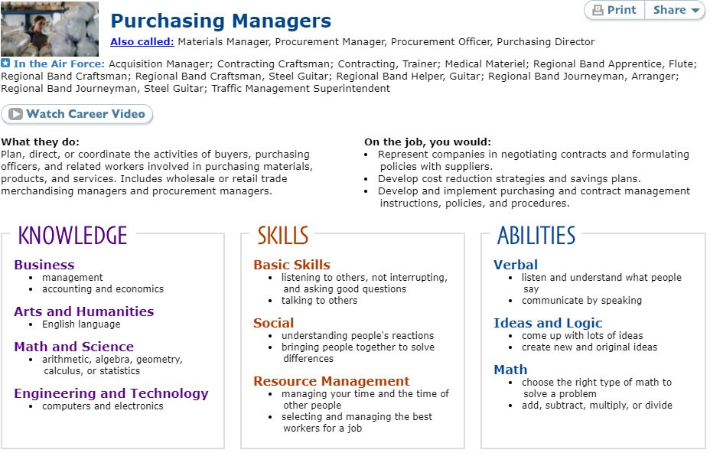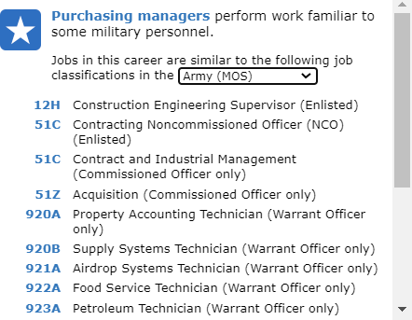

## Example 2 “Search careers with key words”

### Step 1:

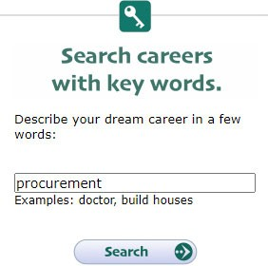

Input the position title or a key word related to the position you are recruiting for.

Click “Search.”

### Step 2:

A list of civilian careers will be displayed. Choose the one, if listed, that most accurately matches your position.

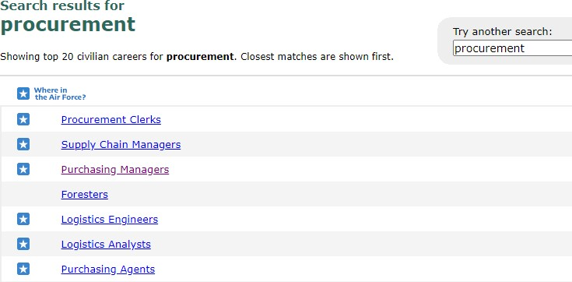

In this case, “Purchasing Manager” is the best match for the procurement manager position being recruited. Click the career to lead to the information page.

### Step 3:

The information page shows what this position may be called in each branch of the military (Shown in Step 3 of Example 1). Using the tip from the first example, click “In the Air Force,” or whichever branch is shown, to see similar military classifications. You can cross reference this list with the veteran’s resume to identify similar jobs. This information can be helpful to understand that even if a veteran did not hold the equivalent title of a procurement or purchasing manager in the military, they could have performed similar duties, and may be capable of transitioning to your recruited position well.

## “CareerOneStop”

“CareerOneStop” offers resources to employers looking to recruit veterans and veterans transitioning to the civilian workforce. This resource is similar to “military.com” and “My Next Move”, providing civilian and military career equivalencies. Below are two translator options available on “CareerOneStop.”

* Civilian‐to‐Military Occupation Translator
  + Hiring managers can use this translator to identify military experience relevant to the civilian recruited position. This tool matches the civilian job title to military careers that use similar skills. Inputting a key word related to a civilian job will produce one or more military occupations that share common skills.

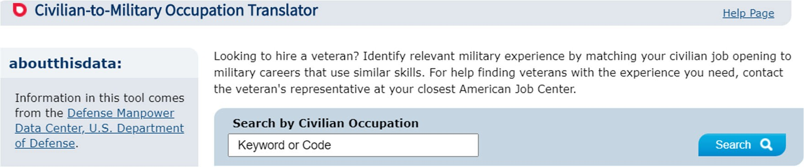

* Veteran and Military Transition Center
  + Veterans can use this site to find resources for employment, training, and other assistance through the Veterans Job Matcher. Here, a veteran can input a military occupation classification (MOC) and military branch and be matched with similar civilian careers.

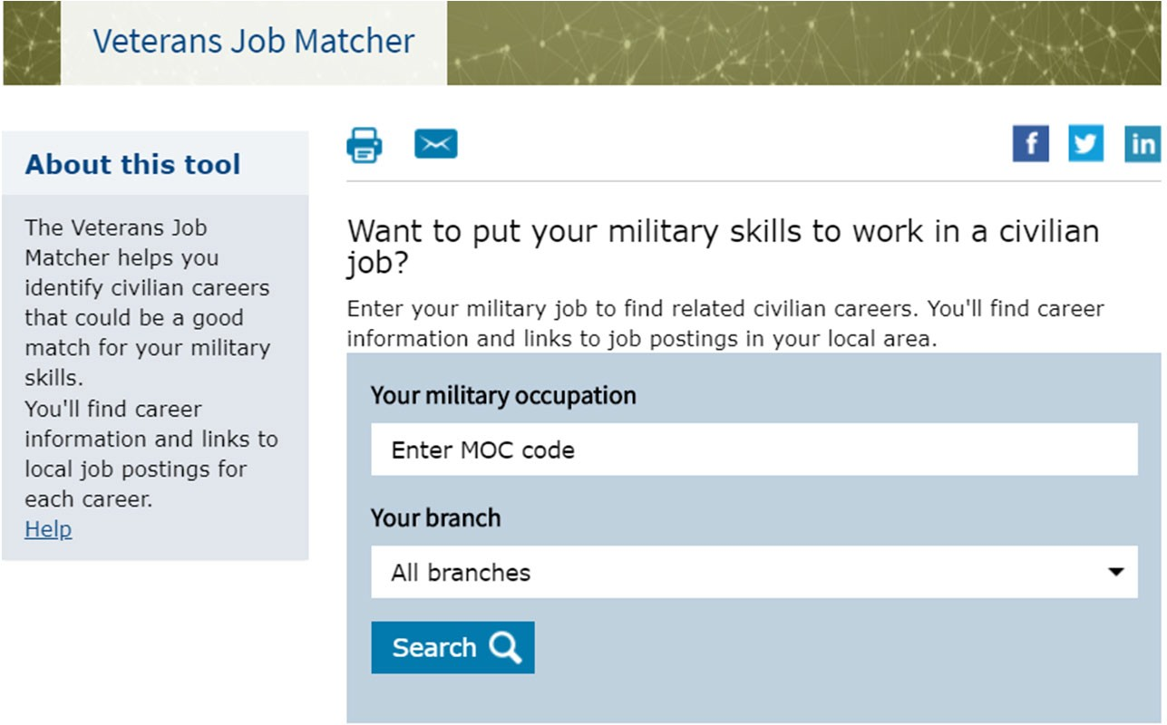

By following the same search methodology as “military.com” and “My Next Move,” hiring managers may use either of these tools to cross reference a military occupation title or code on an applicant’s resume with a civilian position. This will help the hiring manager determine if the applicant possesses experience similar to what is needed.

## O‐Net OnLine

O‐Net also offers a Crosswalk search that matches civilian careers to military occupational classifications (MOC). Like the previous resources, input the branch and MOC or keyword from the veteran applicant’s

resume, click “Go,” and a list of matched careers will be generated.

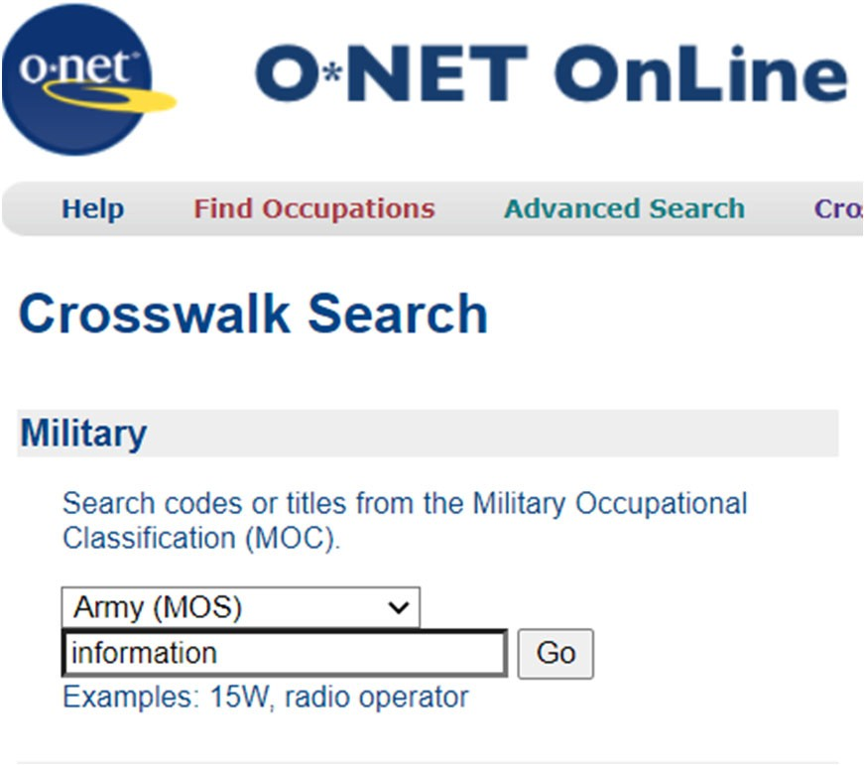

In this example, the key word “information” was used for the search.

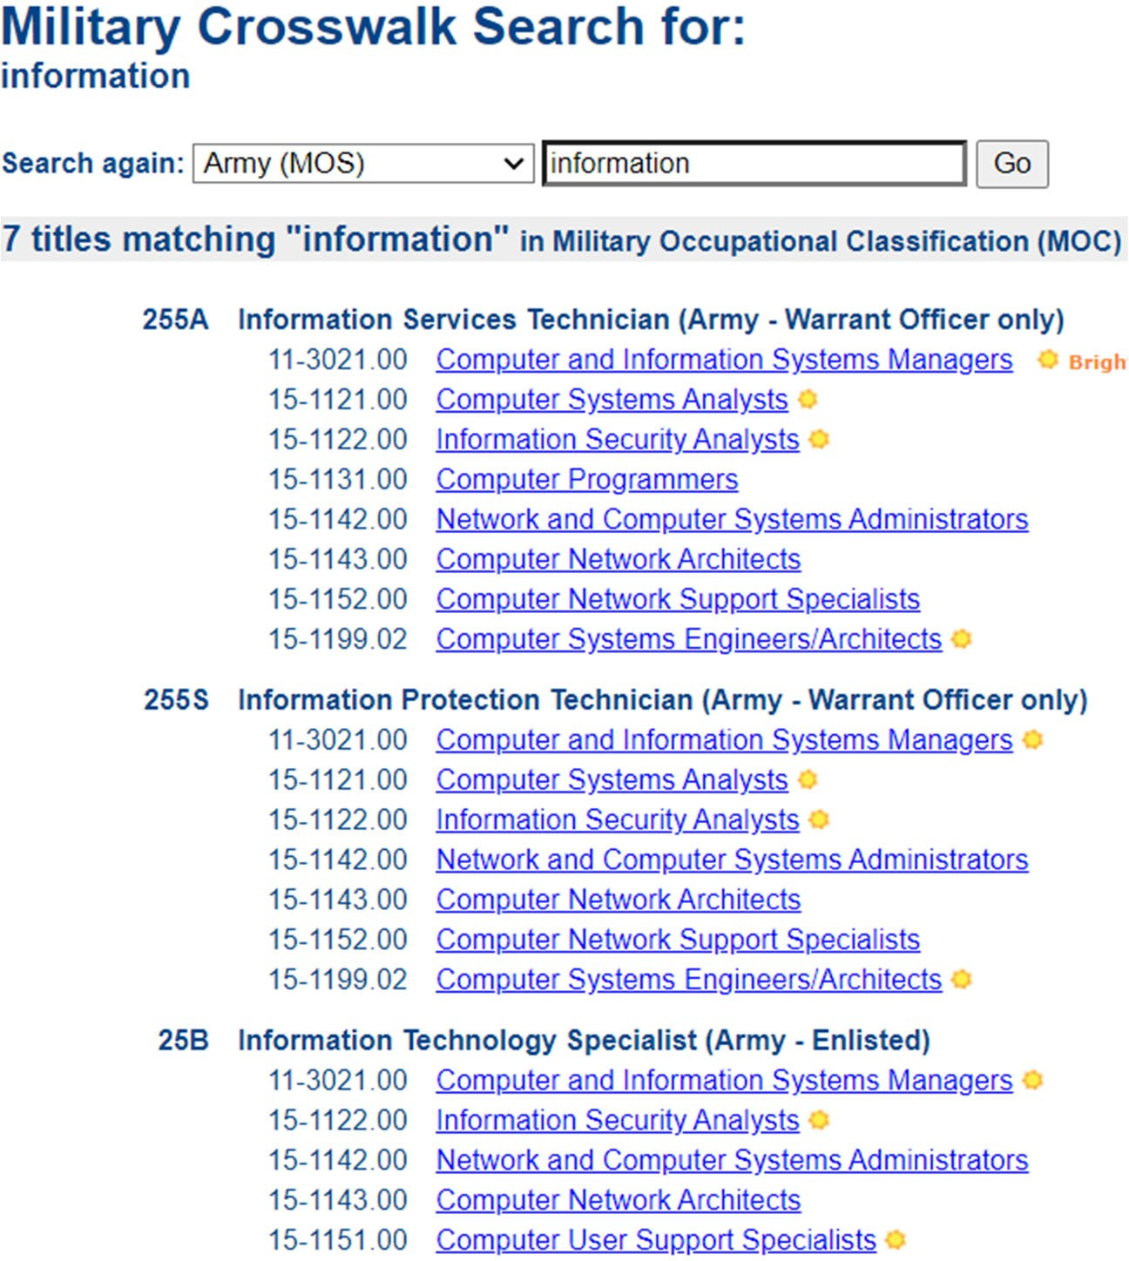

Using this key word, seven military titles matched “information” in the military. Listed below each military title are similar civilian careers.

Clicking any of the careers will direct the hiring manager to a summary page, similar to “My Next Move”, where you can cross reference skills and experience related to these careers.

[www.scdva.sc.gov](http://www.scdva.sc.gov)

For additional assistance, please contact South Carolina Department of Veterans’ Affairs at 803-734-0200 or visit our website at [www.scdva.sc.gov](http://www.scdva.sc.gov).